***SIGNS WITH SMART CONNECTIVITY FOR***

***BETTER ROAD SAFETY.***

ABSTRACT:

A significant amount of research work carried out on traffic management systems, but intelligent [traffic monitoring](https://www.sciencedirect.com/topics/earth-and-planetary-sciences/traffic-monitoring) is still an active research topic due to the emerging technologies such as the Internet of Things (IoT) and Artificial Intelligence (AI). The integration of these technologies will facilitate the techniques for better decision making and achieve urban growth. This research proposes an IoT based system model to collect, process, and store real-time traffic data for such a scenario. The objective is to provide real-time traffic updates on traffic congestion and unusual traffic incidents through [roadside](https://www.sciencedirect.com/topics/engineering/roadsides) message units and thereby improve mobility. These early-warning messages will help citizens to save their time, especially during peak hours. The study is part of the Omani-funded research project, investigating Real-Time Feedback.

KEYWORDS:

Traffic congestion, Road occupancy measure,Vehicle length estimation, Road side message unit, Traffic dashboard.

INTRODUCTION:

The [sustainability](https://www.sciencedirect.com/topics/earth-and-planetary-sciences/environmental-impact-assessment) and smartness of the smart city concept rely on the technologies adopted to improve the people’s quality of life. The smart city governance is one significant aspect of smart city initiatives, which will facilitate the planning techniques for better decision making. One of the key elements of the smart city governance framework is the public value generated out of the smart services provided.

IOT [INTERNET OF THINGS]:

The government has to work on different aspects of smart city solutions such as smart health care, [smart building](https://www.sciencedirect.com/topics/engineering/intelligent-buildings) management, smart traffic management, smart parking solutions, smart transportation, etc. to generate public value for the service they provided. The emergence of the [internet of things](https://www.sciencedirect.com/topics/engineering/internet-of-things) (IoT) has evolved the concept of smart cities. In a smart city environment, the physical infrastructures of the city are equipped with smart devices, which continuously produce multidimensional data in different spaces and these data are processed to achieve intelligence for the infrastructure. Ultimately, intelligence is applied to improve the socio-economic activities of the society.

SMART TRAFFIC INFRASTRUCTURE:

Smart [traffic infrastructure](https://www.sciencedirect.com/topics/earth-and-planetary-sciences/traffic-infrastructure) is an essential component of smart city initiatives because traffic congestion is a severe issue that grows along with city development. Smart traffic management includes intelligent transport systems with integrated components like adaptive traffic signal controls, [freeway](https://www.sciencedirect.com/topics/earth-and-planetary-sciences/motorway) management, emergency management services, and [roadside](https://www.sciencedirect.com/topics/engineering/roadsides) units. Such systems collect real-time traffic data and take necessary measures to avoid or minimize any social issue created as part road congestions. For example, access to real-time [traffic maps](https://www.sciencedirect.com/topics/engineering/traffic-map) will assist the residents in selecting appropriate route to save time and effort.

MOBILE APPLICATIONS:

The widely used mobile applications like Google Maps or Apple Maps accurately predict traffic congestion for urban roads based on the sensor data from monitoring devices installed on highways or urban roads.These application providers establish partnerships with various transportation entities to gather traffic information. The transportation governing authorities mostly install the [traffic monitoring](https://www.sciencedirect.com/topics/earth-and-planetary-sciences/traffic-monitoring) devices on urban roads, hence such application providers (e.g. Google application programming interface) deliver updates on urban traffic congestion. Besides, such applications also use crowd sourcing with location-based services to improve traffic density prediction. They do expect smart technologies within the vehicle or any smart mobile device with the driver of the vehicle to receive real-time traffic updates.

The system follows a layered architecture with four layers

1. a sensing layer with active things and sensors,
2. a network layer represents the mode of communication and protocols,
3. service layer indicates the data analysis and storage,
4. application layer describe the end-user applications.

The sensing layer collects vehicle data through the sensors installed on roadsides and the WiFi-based [microcontroller](https://www.sciencedirect.com/topics/engineering/microcontroller) transfer the real-time data to the service layer. Several open-source cloud IoT platforms are available to manage connected devices, data storage, and analysis. Thinger. io, which is an open-source IoT platform for integrating [data fusion](https://www.sciencedirect.com/topics/earth-and-planetary-sciences/multisensor-fusion) applications acts as a service layer in this study. The end-users receive traffic updates through roadside message display units and dashboards. The physical infrastructures such as sensors and message display units are installed on roadsides at selected road intersections. The message units installed at important road intersections substitutes the smart devices and update drivers on the current traffic scenario. The authorities can also send messages on unusual road incidents along with expected clearance time or alternate route suggestions (if any) to assist emergency vehicle handling. The proposed system aims to generate public value by saving the on-road time of drivers through early warning messages. In summary, the proposed system has the following features:

(i)Appropriate to estimate traffic congestions on collector roads using road occupancy measure.

(ii)Update residents on real-time traffic messages through roadside display units.

(iii)Monitor the road density of smart campuses especially during peak hours and help to improve mobility.

(iv)Assist authorities to broadcast important traffic incident messages.

(v)Provide a real-time dashboard to monitor the traffic updates.

RELATED WORK:

This section first discusses the recent research developments in intelligent traffic management including system models for traffic updates, traffic congestion measures, emergency vehicle handling, and applications of [roadside](https://www.sciencedirect.com/topics/engineering/roadsides) units to deliver messages. Current advances in cost-effective and power-efficient [wireless sensor nodes](https://www.sciencedirect.com/topics/engineering/wireless-sensor-node) for [traffic monitoring](https://www.sciencedirect.com/topics/earth-and-planetary-sciences/traffic-monitoring) follow this. This section also includes specific [printed circuit boards](https://www.sciencedirect.com/topics/engineering/printed-circuit-board) based on [sensor nodes](https://www.sciencedirect.com/topics/engineering/sensor-node) to detect vehicles, estimate speed, and classify them. The discussion includes the features of these nodes, their pros, and cons.

REAL TIME TRAFFIC UPDATES:

Real-time traffic monitoring systems play a key role in the transition toward smart cities. A considerable amount of literature has been published on intelligent traffic management systems based on the  [IoT](https://www.sciencedirect.com/topics/engineering/internet-of-things)  paradigm. Autonomous traffic sensing is at the heart of smart city infrastructures, wherein smart wireless sensors are used to measure traffic flow, predict congestion, and adaptively control traffic routes.

Most of the recent developments in delivering real-time traffic updates used the congestion estimates to dynamically control the traffic signal. An IoT based real-time traffic monitoring system is proposed for dynamic handling of traffic signals based on traffic density. The proposed system uses a set of [ultrasonic sensors](https://www.sciencedirect.com/topics/engineering/ultrasonic-sensor) and has two modules:

one for vehicle monitoring and other for priority management. The ultrasonic sensors are used to detect vehicles, and the density levels of a given road are sent to an LCD, and the data sent to the server for later usage. In similar research, the authors proposed an ultrasonic sensor-based system model specifically for road intersections. In addition to traffic signal lightings, the system alarms on any false vehicle activities such as crossing the red signals. In another research, an IoT based smart traffic management system is proposed to manage real-time traffic through both central and local servers.The data collection layer uses sensors, cameras, and RFIDs. The application layer automatically controls the traffic signal based on traffic density and provides a daily report through a web application. Besides sensors, video monitoring is also used to estimate traffic congestion density and update traffic signals in real-time.

WIRELESS SENSOR FOR VEHICLE:

This section presents the review of sensors that are used for vehicle detection and classification. The sensors used in intelligent traffic monitoring systems can be on-road sensors or in-vehicle sensors. The on-road traffic sensors can be again classified into two types:

1. intrusive
2. non-intrusive.

The intrusive sensors are paved on the road and are costly compared to non-intrusive sensors. The intrusive sensors provide accurate information; however, they are questioned for the expenses in terms of installation. maintenance, repair costs . The maintenance of such sensors requires road lane closures and traffic disruptions.

The non-intrusive sensors can be fixed on different parts of roads/roadsides. This includes magnetic sensors , ultrasonic sensors , infrared sensors , acoustic sensors , video cameras.

Each sensor has its advantages and disadvantages. The ultrasonic sensors are prone to environmental factors. The video monitoring systems are comparatively costly than other sensors when considering the purchase, installation, and maintenance costs . However, the sensors are relatively less expensive in purchase costs.The magnetic sensors are unable to detect the vehicles which are not moving however, there is no climatic influence. The magnetic sensors are widely used for vehicle detection and classification because of its easy installation, portability, and low cost. The vehicle speed and length can be estimated by one or more magnetic sensors, which will help to approximate the road space occupancy measure.

(i)PRS [Portable Roadside Sensor]:

PRS is a portable roadside sensor for vehicle detection, counting, classification, and speed estimation. PRS uses a magnetic sensor for vehicle detection. The single PCB board of PRS contains two magnetic sensors (HMC2003). This sensor uses the XBee module for [wireless communication](https://www.sciencedirect.com/topics/earth-and-planetary-sciences/wireless-communication). PRS shows an accuracy of 99% in vehicle detection, and the maximum error rate of speed estimation is 2.5% (in a range of 5–27 m/s). Besides, the system also detects the right intersection. The vehicle length and height are estimated from the magnetic length.

(ii)LCTS [Low-speed Congested Traffic Sensor node]:

LCTS is another low-speed congested traffic sensor node with a magnetic sensor specifically for a single lane road. The sensor node is designed using magnetic sensor HMC5883L. In addition to the magnetic sensor, the node also contains a sound sensor and four infrared sensors. However, the magnetic sensor alone performs vehicle detection and classification. The validation results show a detection accuracy of 99.05% and a [classification accuracy](https://www.sciencedirect.com/topics/engineering/classification-accuracy) of 93.66%.

(iii)IVCCS [Intelligent Vehicle Counting &Classification Sensor]:

The iVCCS is an [intelligent vehicle](https://www.sciencedirect.com/topics/engineering/intelligent-vehicle-highway-systems) counting and classification sensor; the node has different sensors and components such as temperature sensor, [accelerometer](https://www.sciencedirect.com/topics/earth-and-planetary-sciences/accelerometer), magnetic sensor, [GPS](https://www.sciencedirect.com/topics/earth-and-planetary-sciences/global-positioning-system) module, real-time clock unit, memory unit, etc.. The iVCCS is a small battery-powered node with a 6-axis magnetic sensor and accelerometer FXOS8700. It uses a Zigbee wireless communication.

(iv)CPIUS [Combined Passive Infrared &Ultrasonic Sensor]:

CPIUS is the combined passive infrared and ultrasonic sensors (CPIUS) for vehicle classification and speed estimation. The measurements from passive infrared sensors and ultrasonic sensors are used for vehicle classification. They produce a high accuracy in vehicle detection (99%), the [mean absolute error](https://www.sciencedirect.com/topics/engineering/mean-absolute-error) in speed estimation is approximately 5.87 km/h, and a mean absolute error of 0.73 m in vehicle length estimation.

RESEARCH METHODOLOGY:

A robust research methodology is essential to achieve the research objectives. This research work is carried out in five main phases according to [design science research](https://www.sciencedirect.com/topics/engineering/design-science-research) methodology. The five phases are given in

1. research background study,
2. objective definition,
3. design and development of [artifacts](https://www.sciencedirect.com/topics/engineering/artefact),
4. demonstration to show how the artifacts resolve the problems,
5. final evaluation.

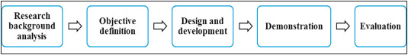

SYSTEM DESIGN AND DEVELOPMENT:

This section discusses the proposed system model, different software and hardware components required, and algorithms to implement the proposed system. The proposed system communication model is presented in which has components installed at the roadside and a cloud-based central server. The roadside setup includes sensors and message boards. The sensors and boards will be installed between two road segment intersections. The central server includes data storage, cloud services, and interfaces. The components can communicate with each other using WiFi.

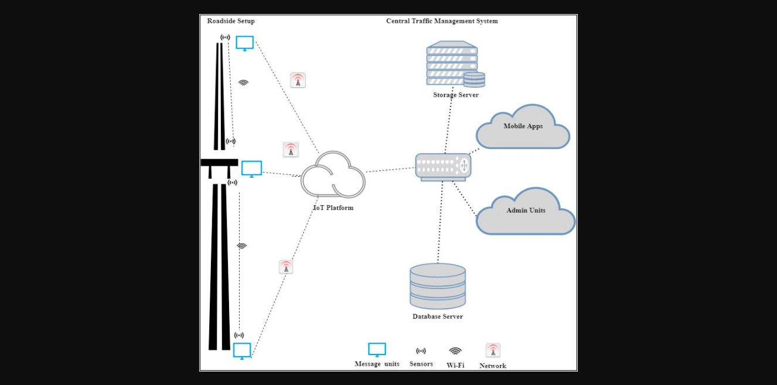

SYSTEM ARCHITECTURE:

The four main system development activities are:

1. populate geographical map details for a given location,
2. detect vehicle and estimate vehicle length,
3. determine growing queue,
4. display traffic updates.

The system components include

1. Geographical map,
2. Sensors,
3. Microcontroller,
4. IoT platform
5. Database,
6. Electronic display units.

The activities, the software, and hardware components associated with each activity are given in below figure.,

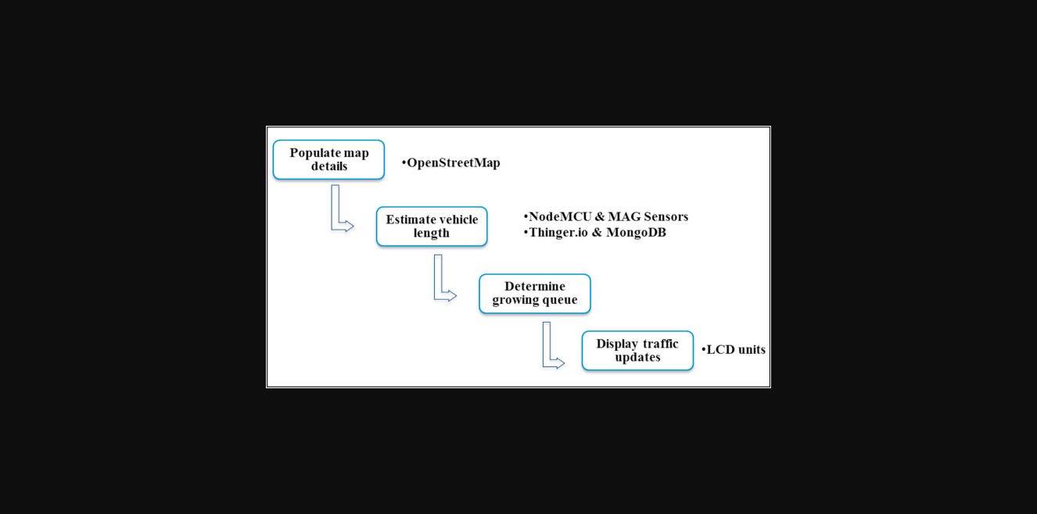

EXPERIMENTS & DISSCUSSION:

An experiment has been conducted to demonstrate the [feasibility](https://www.sciencedirect.com/topics/earth-and-planetary-sciences/feasibility) and applicability of the proposed system. A [proof of concept](https://www.sciencedirect.com/topics/engineering/proof-of-concept) system is developed. The experiment execution steps are as follows

1. Load geographical map details.
2. Conduct on the road test for vehicle detection, vehicle length estimation, and road occupancy measurement.
3. Traffic dashboard creation from real-time data. The communication model of the prototype.
4. The experiment used a single node for vehicle detection and a simulation scenario for road occupancy measurement.

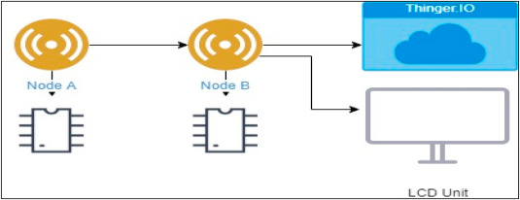

The hardware and software components used for the prototype implementation is discussed in detail under section. The hardware and software components required to set up the experiment are:

1. HMC5883L, Node MCU ESP8266, LCD unit, [Breadboard](https://www.sciencedirect.com/topics/engineering/breadboard), Jumper wires, USB cable
2. Arduino IDE, Thinker cad, Mongo DB, OSM file.

EVALUATION:

A step-by-step evaluation process has been executed to validate three main functionalities:

1. Map processing and selection of message board location.
2. Vehicle data collection and processing.
3. Dashboards.

DISSCUSSION:

The study proposed a system model for real-time traffic updates in an IoT context to assist drivers. The system has three main functionalities:

1. Map processing
2. Traffic data collection
3. Visualization
4. Storage.

The system uses an existing free wiki map to collect the road information and extract the message unit location. The data collection layer is built on magnetic sensors to detect vehicles and estimate the length of the vehicle and road occupancy. The [feasibility](https://www.sciencedirect.com/topics/earth-and-planetary-sciences/feasibility) of the system is demonstrated through a prototype. Each of the modules is evaluated individually, and the results of the evaluation are satisfactory in terms of accuracy. The system architecture establishes a WiFi-based communication model between sensors and the IoT platform. The roadside magnetic sensors and the micro-controller follows a client-server WiFi communication.

CONCLUSION:

This research proposed an IoT based system model to collect, process, and store real-time traffic data. This research provided real-time traffic monitoring for traffic updates through roadside message units. The traffic authorities can also broadcast messages on [VIP](https://www.sciencedirect.com/topics/medicine-and-dentistry/vasoactive-intestinal-polypeptide) visits, medical emergencies, accidents, etc. to corresponding message units, which will assist the public in decision making and save their time on roads. The proposed system uses magnetic sensor nodes to collect real-time vehicle information. The real-time data is processed by WiFi-enabled microcontrollers and sends to an IoT platform for further actions. Whereas, the proposed system does not expect any smart equipped devices with the driver of the car or within the car such as sensors, [GPS](https://www.sciencedirect.com/topics/earth-and-planetary-sciences/global-positioning-system), WiFi, etc. and which makes this model unique. The traffic administration can send priority messages to the citizens; hence, the traffic congestion due to accidents or any such unusual incidents can be avoided.